
Email:milleniumstar.enterprise@ymail.comTelefax:(049)5081582

QUOTATION
To:PriconMSE111119
Attn:Ms.Rebecca ValenzuelaNov.11,2019
CC:Mr.Arnold Martinez
Subject:inquiry
Maam,
We are pleased to quote you as follows.We highly appreciated your interest in our company.
And we are looking forward in seeing your purchase order.Thank you very much for your inquiry.
ITEM QTY. DESCRIPTION Unit Price Total Amount
1 1 unitTable lifter Usd2450.00/pc Usd2450.00
Stationary Scissors Table Lift SJG0.5-1.0 Configuration (Picture is for reference)
1. Main structure of the Scissors: 100*50*5mm Manganese steel tubes.
2. Lowered height: 200mm (Customized)
3. Working pressure: 10Mpa
4. Surface board: 3mm steel board
5. Power: 2.2Kw.
6. Electrical parts: Delixi Brand
7. O-Ring: Valqua, Japan
8. Bearing: SF-1 auto-lubricating bearing without lube.
9. Pump station: Germany &Taiwan joint venture company.
10. Control mode: Electric control by control cabinet and hand control panel.
11. Cylinder: Wearable fine cylinder with double O-ring,

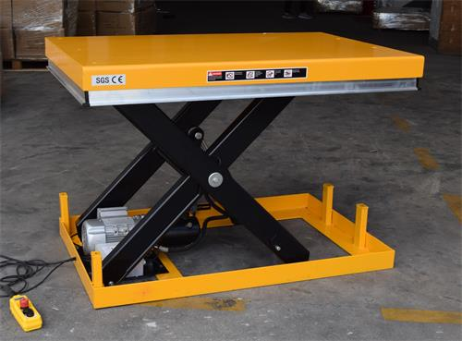
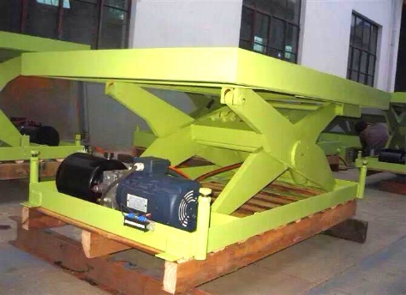

12. Hydraulic oil pipe: High pressure double steel net rubber pipe
13. Hydraulic oil: 32# wearable hydraulic oil, The Grate Wall brand.
14. Package: Standard export wooden package.
Note: With emergency drop valve, in case of power failure to drop the table to ground.
With safety bars in case any harm to body when table closing.
Note: Base size is 1200mm*650mm

2. 1set stainless top and MS block Usd1570.00/set Usd1570.00

Delivery:4 weeks
Terms:End of next month after the month end closing

If you have any queries please don’t hesitate to contact us
Sincerely ,
Johnna Villaceran

